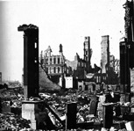


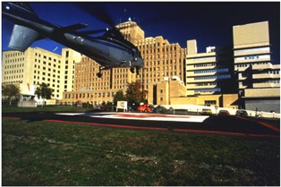
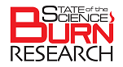
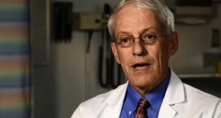
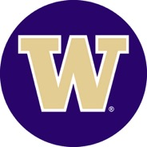
Occupational Medicine Grand Rounds: Returning to Work after Burn Injury: Barriers and Opportunities Nicole S. Gibran, MD, FACS

November 18, 2015
The National Fire Protection Association (NFPA) established Fire Prevention Week to commemorate the Great Chicago Fire that killed more than 300 people in 1871. To learn more about this historic event, visit The Weather Channel and view a short informative video: https://www.youtube.com/watch?v=a3Q3wwRAGiw

A goal of the NFPA is to eliminate fire deaths and injuries through public education programming and information. The 2015 Fire Prevention Week theme is ‘Hear the Beep Where You Sleep. Every bedroom needs a working smoke alarm!” Visit their website for more information on their annual Fire Prevention Week campaign (http://www.nfpa.org/safety-information/fire-prevention-week).

Take it one step further and test your knowledge on this important topic -- take the Fire Prevention Quiz at http://www.nfpa.org/safety-information/fire-prevention-week/fire-prevention-week-quiz.

February 22-23, 2016
2016 State of the Science Meeting for Burn Research Washington DC.

October 4-10, 2015
National Fire Prevention Week

Fire Prevention
Join us on Facebook and Twitter to learn more about our research and educational efforts.

What’s New?
If you would like to receive a copy of our newsletter, email us at NWRBMS@uw.edu and request either an email or paper copy. Please include the appropriate email or postal address with your request.

NWRBMS Fall 2015 Newsletter
  - UW Medicine Regional Burn Center at Harborview Medical Center
  - Seattle, Washington
Fall 2015 Newsletter

Northwest Regional Burn Model System

Next year promises to be a year filled with opportunities to learn about new advances concerning burn care and research. In February, experts and burn survivors from all over North America will gather in Washington DC to discuss the progress achieved in burn research for both acute and rehabilitative care. Speakers will detail advances and new information learned in the past 10 years with an emphasis on outcomes -- especially those reported by burn survivors. This 2-day seminar will include both didactic and small group discussions with the goal of identifying acute care and rehabilitation research priorities for the future. To learn more about this educational offering, visit the American Burn Association website at: http://www.ameriburn.org/2016%20NLC_SOS_SaveTheDate.pdf.
In May, members of the burn team to include clinicians, burn survivors, firefighters, and researchers will gather in Las Vegas to attend the 48th Annual American Burn Association Meeting. Several members of the UW Medicine Regional Burn Center here at Harborview will be attending with many of them speaking. Dr. Nicole Gibran (Burn Center Director and Principal Investigator of the Northwest Regional Burn Model System - NWRBMS) and Gretchen Carrougher RN, MN (NWRBMS project coordinator) will moderate a 2-day postgraduate course concerning ‘Delirium and Post-intensive Care Syndrome.’ Many of our members will be sharing highlights of their research and quality improvement studies at this meeting. Once the conference agenda is finalized, we will be posting information on our NWRBMS Facebook page and twitter @NWRBMS.

Looking Ahead to 2016
Fall 2015

Emergency planning saves lives!

Design an escape plan from your home. Practice your escape plan with the entire family at least two times a year. If your escape route involves an upper level window or balcony, plan a safe way to get to the ground.

Have a working smoke detector in your home.

Most fire deaths are caused by smoke and toxic gases - not flames.
Visit
http://www.msktc.org/burn/Hot-Topics/Employment
Watch the video clips about employment after a burn injury

Visit our website at http://burnrehab.washington.edu/
Injury Prevention Tips

